**Assignment No:-20**

Name:-Suryawanshi Sangramsingh Sambhaji

Batch: - Delta - DCA (Java) 2024 Date:-30/5/2024

**Q4.Given an array A[] consisting of only 0s, 1s, and 2s. The task is to write a function that sorts the given array.**

**The functions should put all 0s first, then all 1s and all 2s in last.**

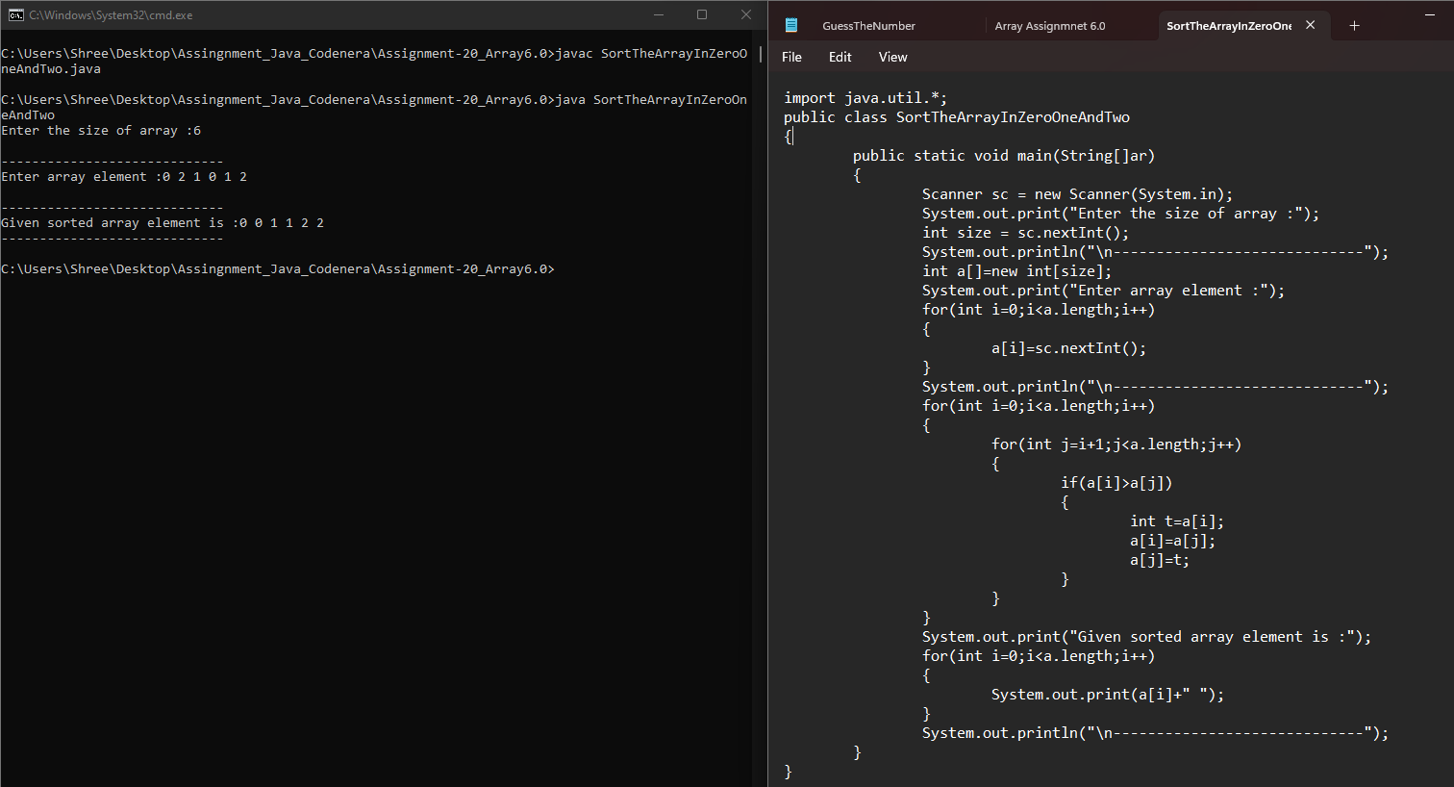

**Q5.Given two sorted arrays, find their union and intersection.**

**Example:**

**Input: arr1[] = {1, 3, 4, 5, 7}, arr2[] = {2, 3, 5, 6}**

**Output: Union: {1, 2, 3, 4, 5, 6, 7}, Intersection: {3, 5}**

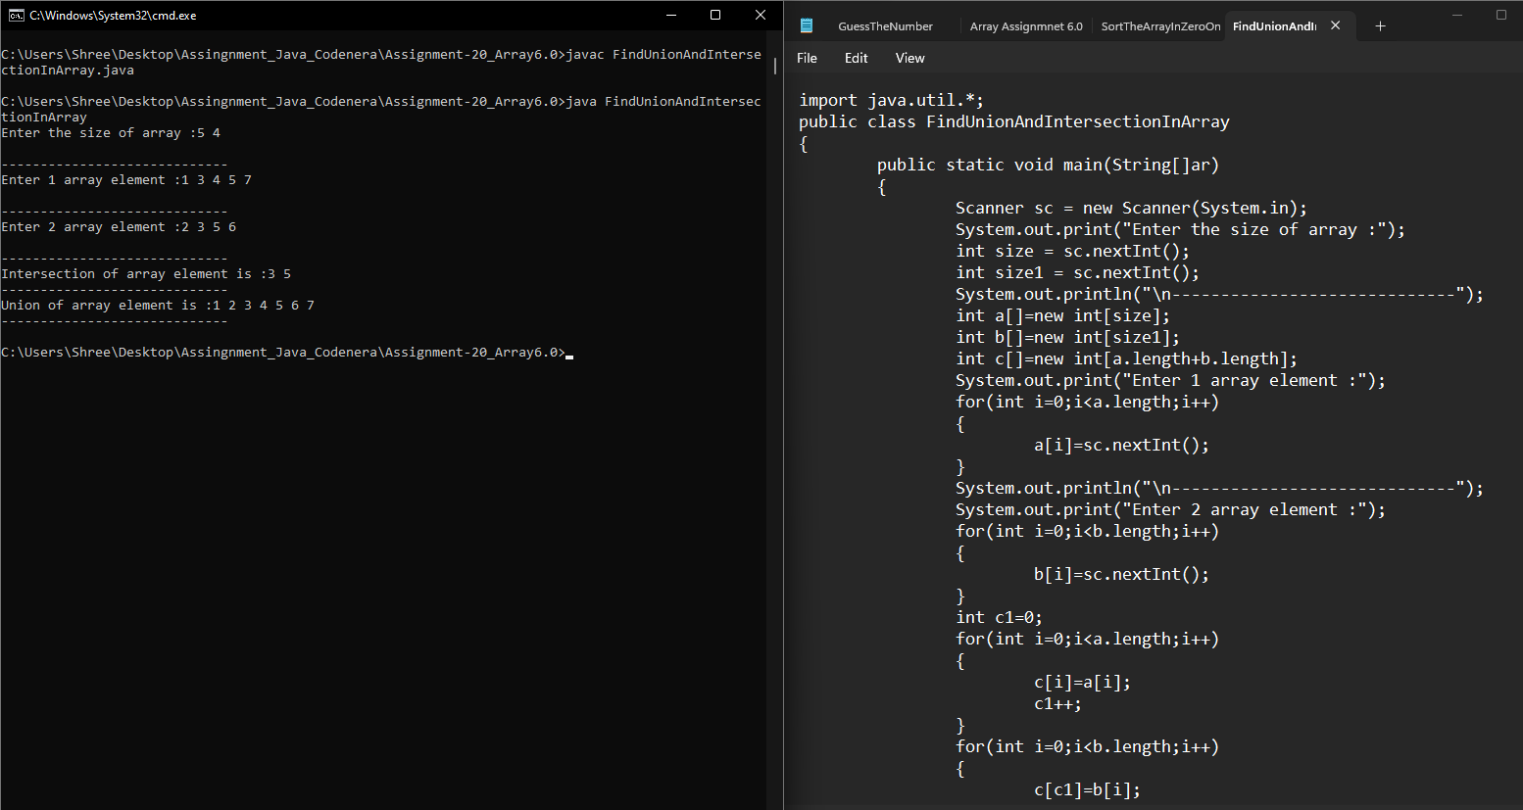 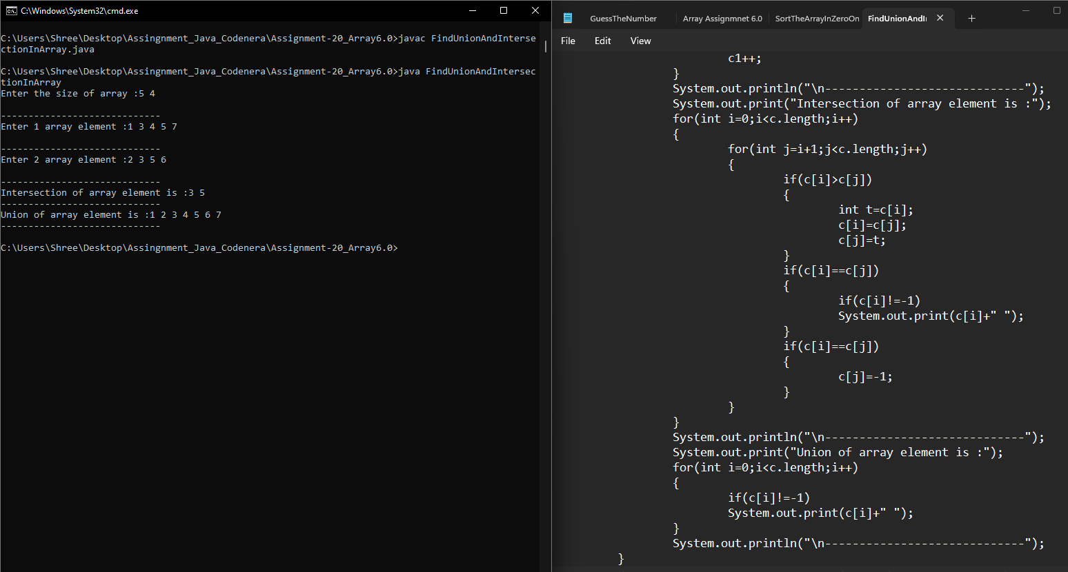

**Q6.Given an array, cyclically rotate the array clockwise by one.**

**Examples:**

**Input: arr[] = {1, 2, 3, 4, 5}**

**Output: arr[] = {5, 1, 2, 3, 4}**

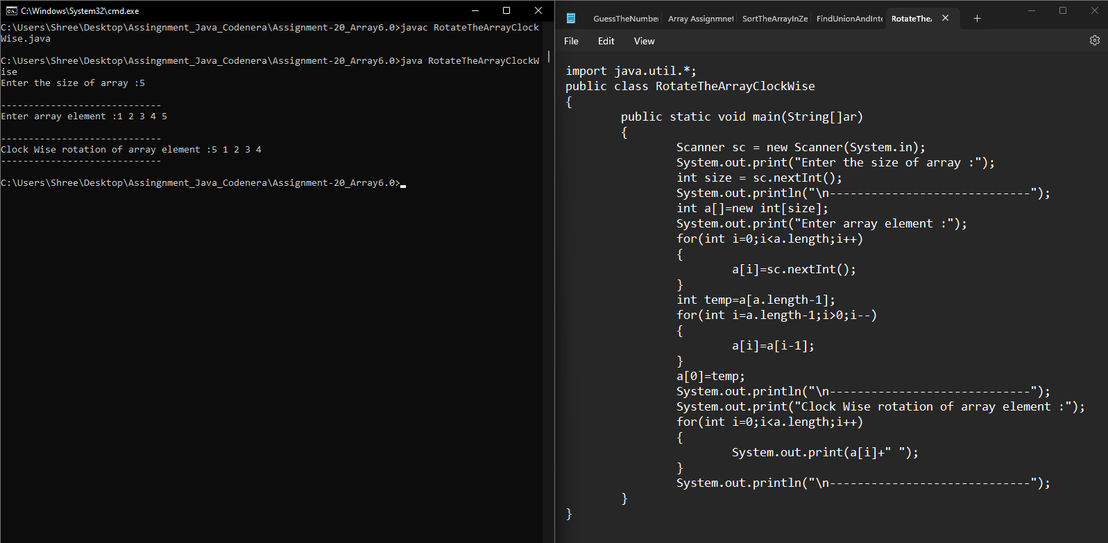

**Q7.Given an array arr[] of size N-1 with integers in the range of [1, N], the task is to find the missing number from the first N integers.**

**Note: There are no duplicates in the list.**

**Examples:**

**Input: arr[] = {1, 2, 4, 6, 3, 7, 8}, N = 8**

**Output: 5** 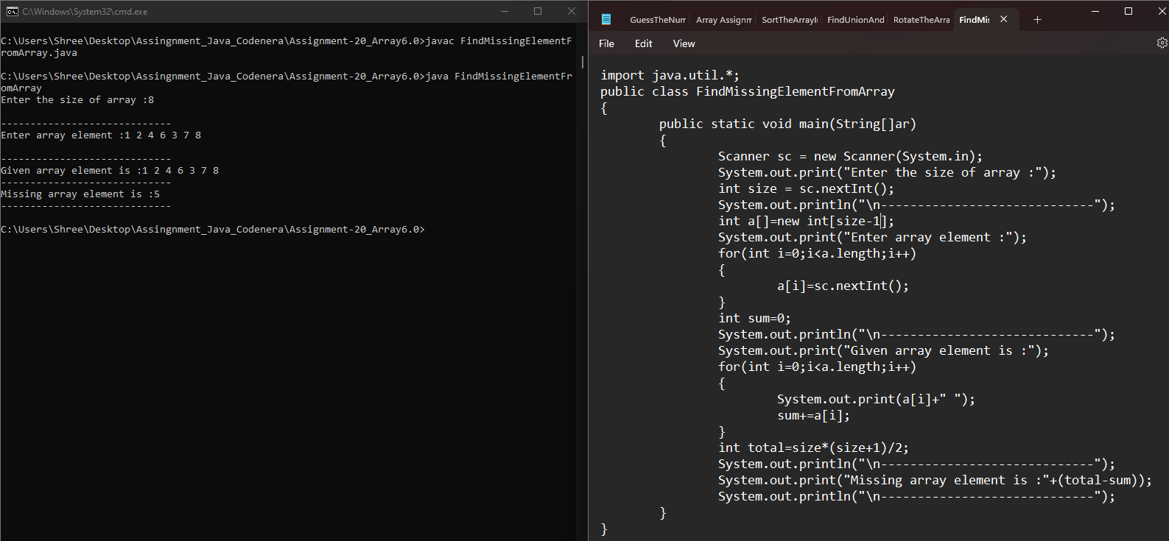

**Q8.Given three arrays sorted in non-decreasing order, print all common elements in these arrays.**

**Examples:**

**Input:**

**ar1[] = {1, 5, 10, 20, 40, 80}**

**ar2[] = {6, 7, 20, 80, 100}**

**ar3[] = {3, 4, 15, 20, 30, 70, 80, 120}**

**Output: 20, 80**

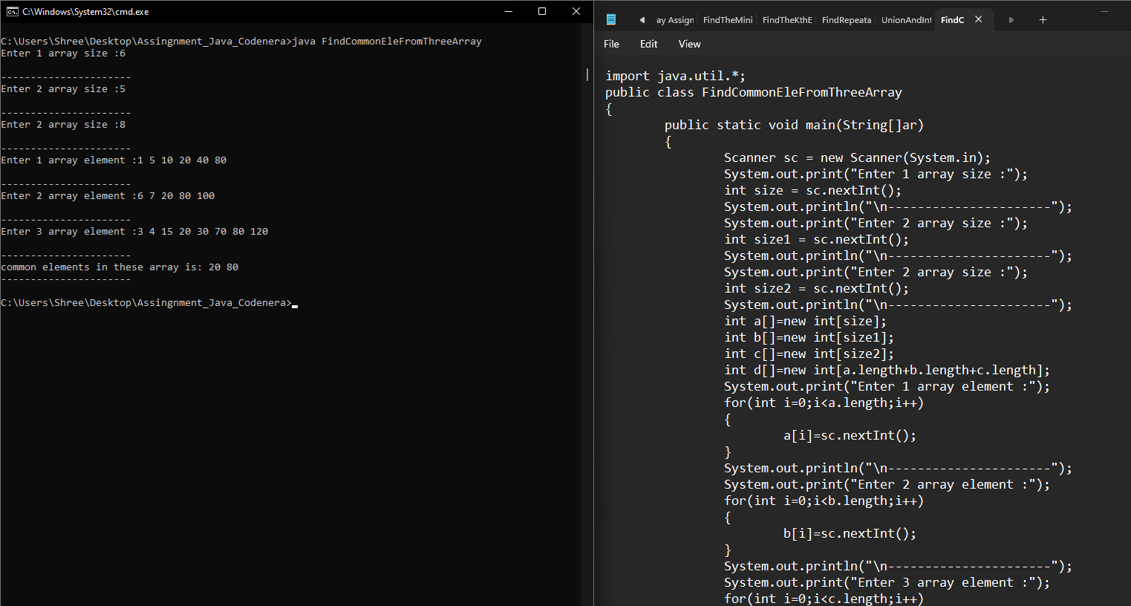

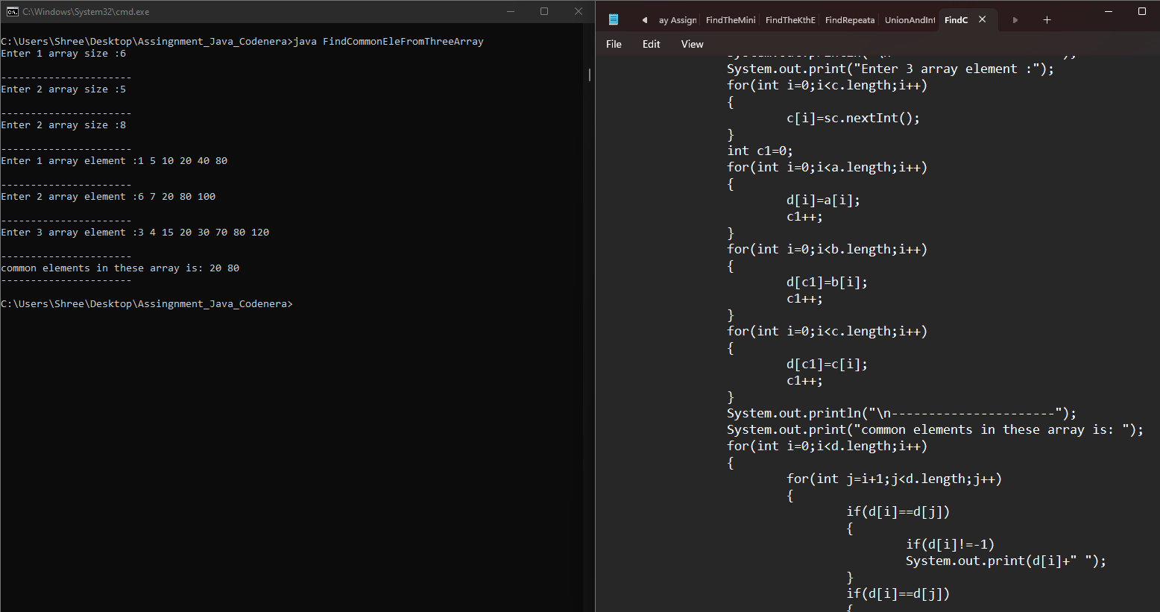 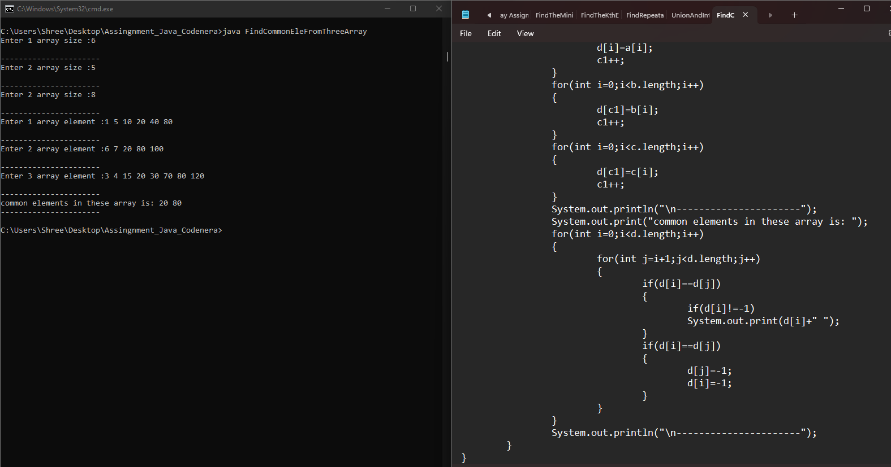

**Q9.Given an array of integers arr[], The task is to find the index of first repeating element in it i.e. the element that occurs more than once and whose index of the first occurrence is the smallest.**

**Examples: Input: arr[] = {10, 5, 3, 4, 3, 5, 6}**

**Output: 5**

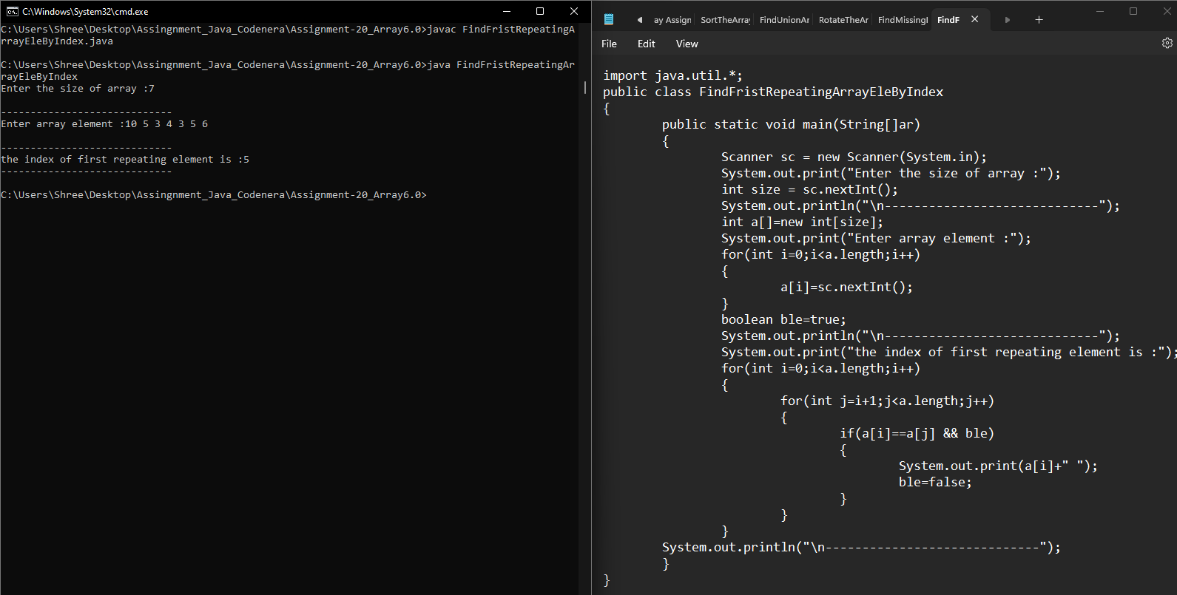

**Q10.Given the heights of N towers and a value of K, either increase or decrease the height of every tower by K (only once) where K > 0. After modifications, the task is to minimize the difference between the heights of the longest and the shortest tower and output its difference. Examples: Input: arr[] = {1, 15, 10}, k = 6**

**Output: Maximum difference is 5.**

**Explanation: Change 1 to 7, 15 to 9 and 10 to 4. Maximum difference is 5 (between 4 and 9). We can’t get a lower difference.** 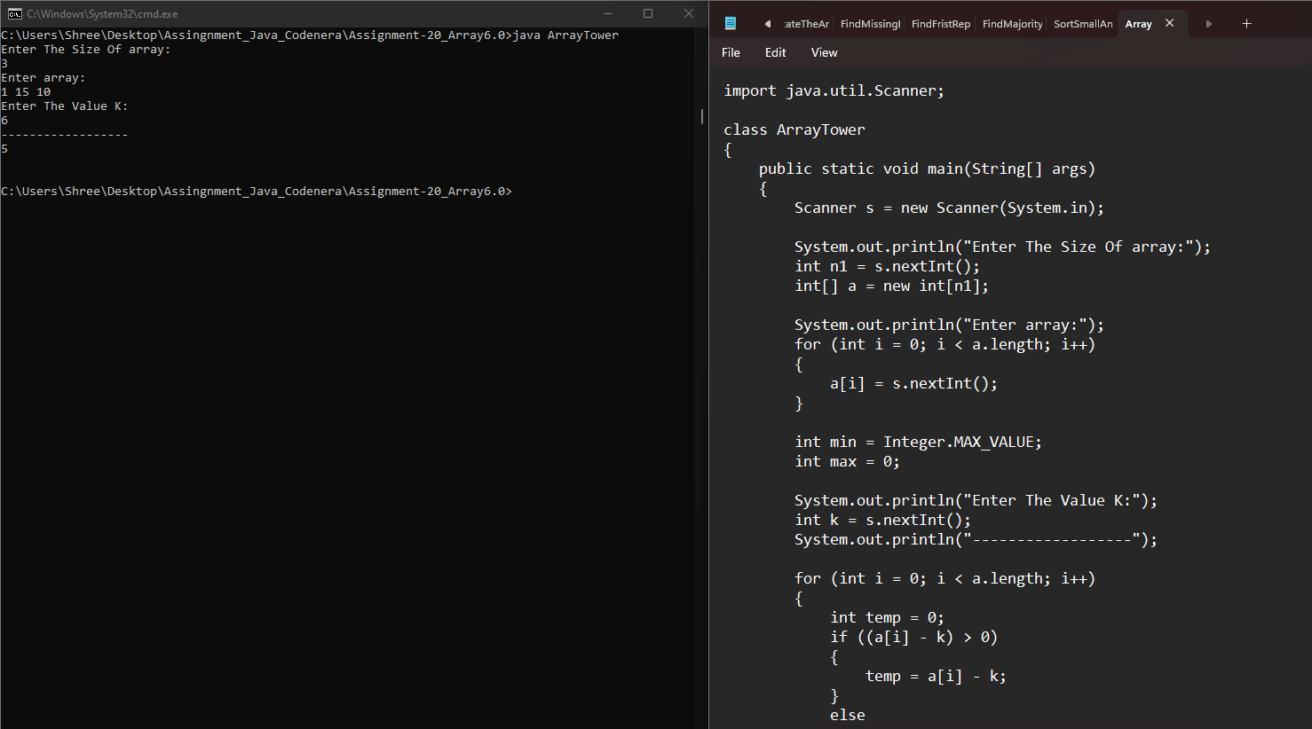 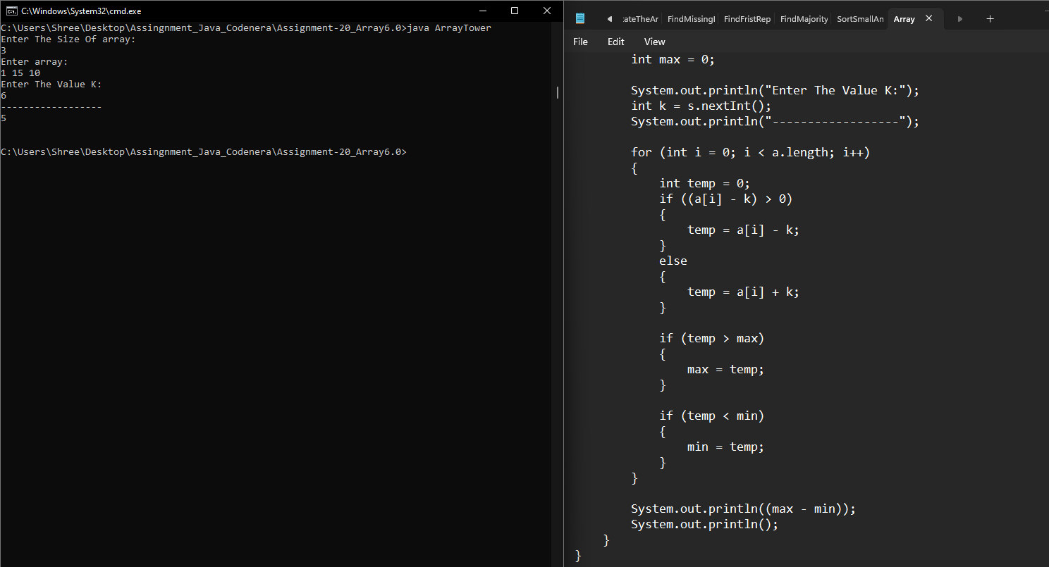

**Q11.Given an unsorted array arr[] with both positive and negative elements, the task is to find the smallest positive number missing from the array.**

**Note: You can modify the original array.**

**Examples:Input: arr[] = {2, 3, 7, 6, 8, -1, -10, 15}**

**Output: 1**

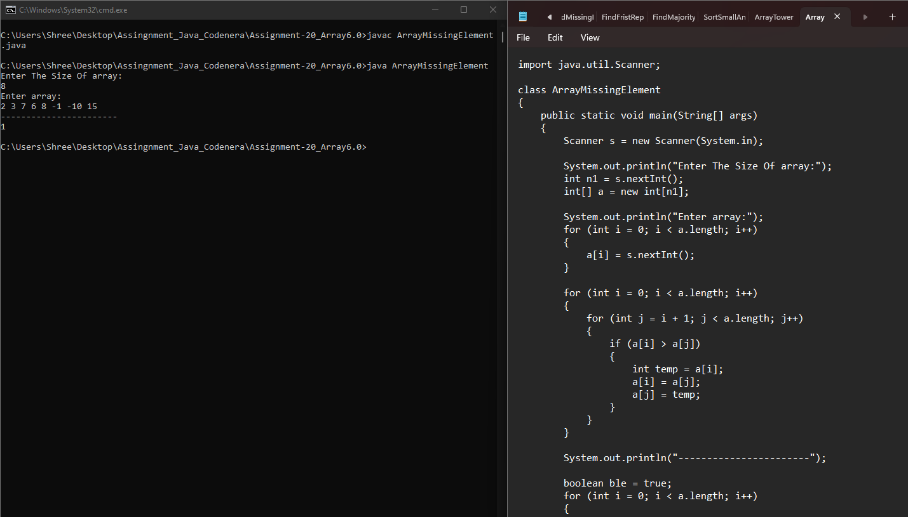 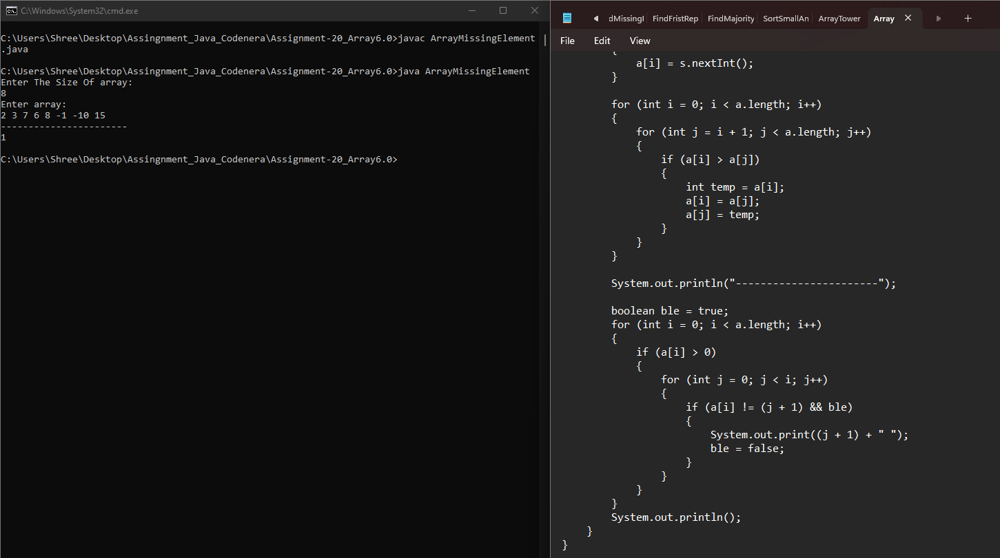

**Q12.Find the majority element in the array. A majority element in an array A[] of size n is an element that appears more than n/2 times (and hence there is at most one such element).**

**Examples :**

**Input : {3, 3, 4, 2, 4, 4, 2, 4, 4}**

**Output : 4**

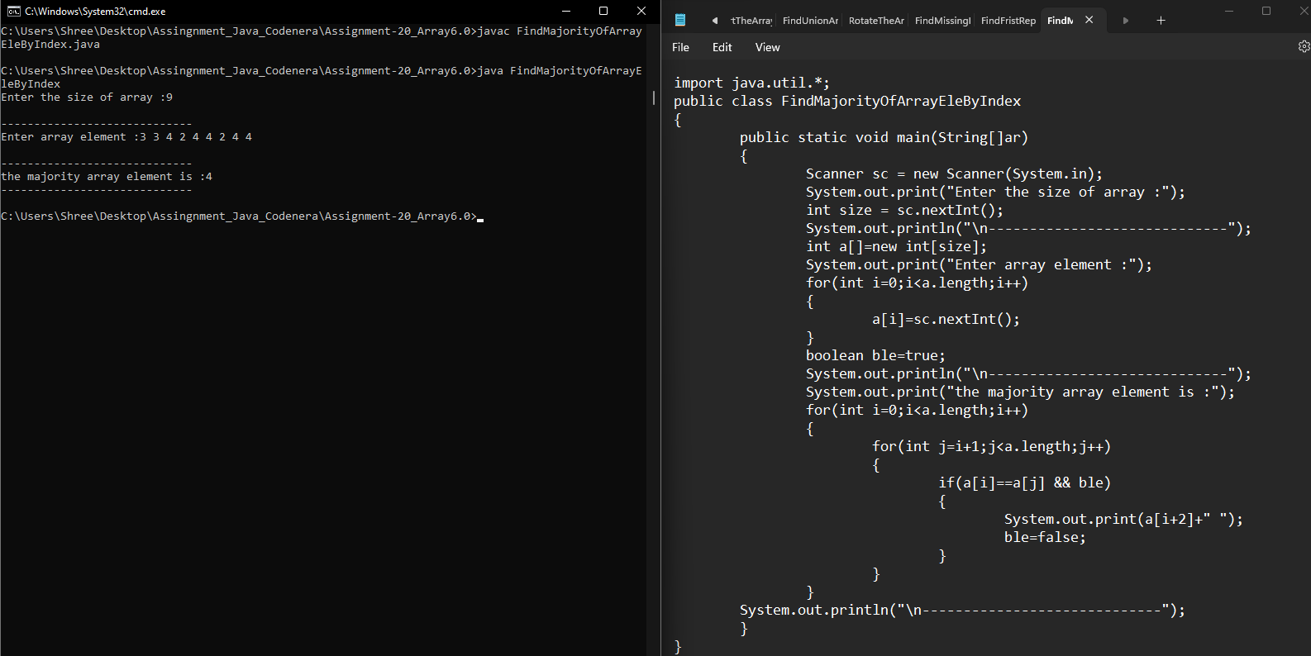

**Q13. Given two sorted arrays A and B of size p and q, write a Java program to merge elements of A with B by maintaining the sorted order i.e.**

**fill A with first p smallest elements and fill B with remaining elements.**

**Example: Input :**

**int[] A = { 1, 5, 6, 7, 8, 10 }**

**int[] B = { 2, 4, 9 }**

**Output:**

**Sorted Arrays:**

**A: [1, 2, 4, 5, 6, 7]**

**B: [8, 9, 10]** 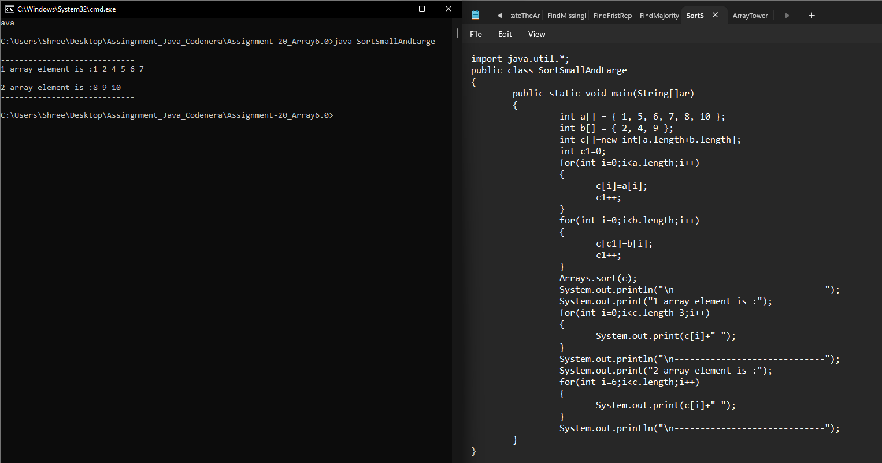

**Q14.Write a Java program to find maximum product of two integers in a given array of integers.**

**Example:**

**Input : nums = { 2, 3, 5, 7, -7, 5, 8, -5 }**

**Output: Pair is (7, 8), Maximum Product: 56**

